Who:
Whoami:

uname:

mkdir:

cut:

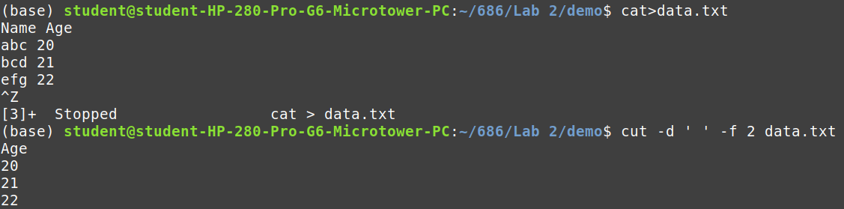
PART-B

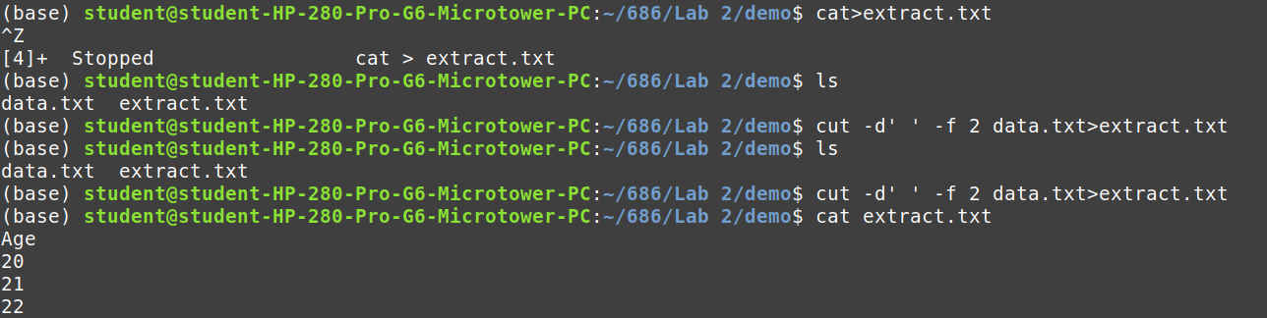
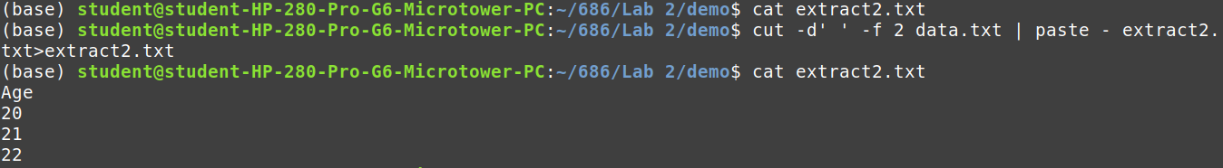

3.
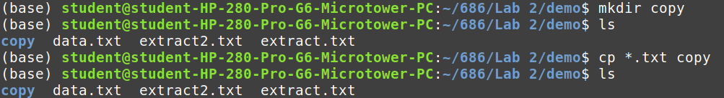
2.
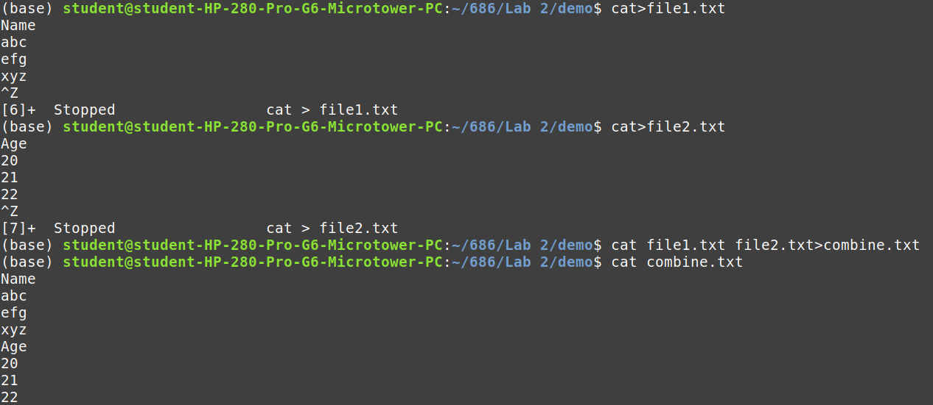
4.

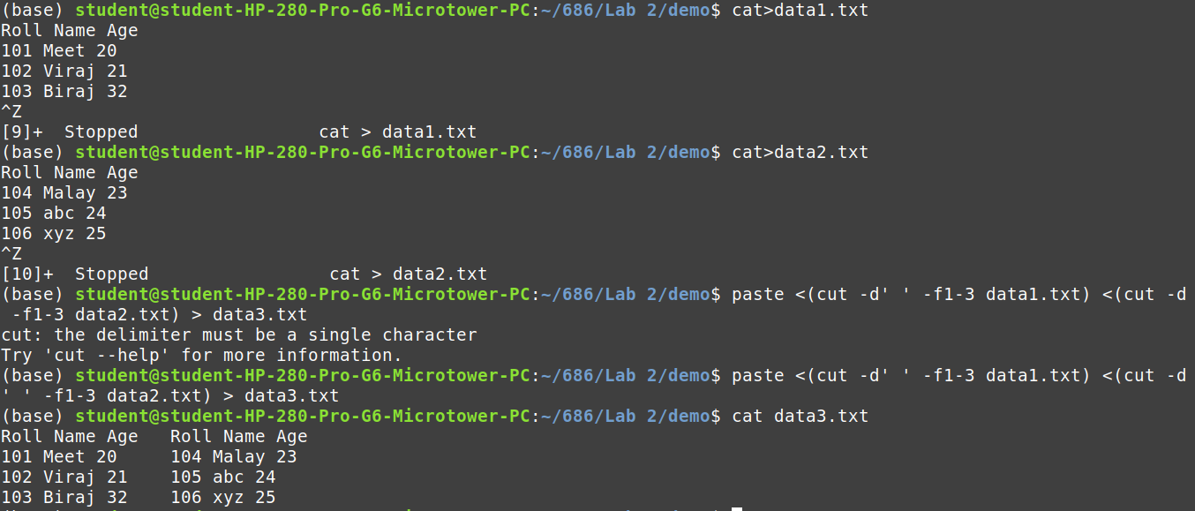
PART – C:
1
